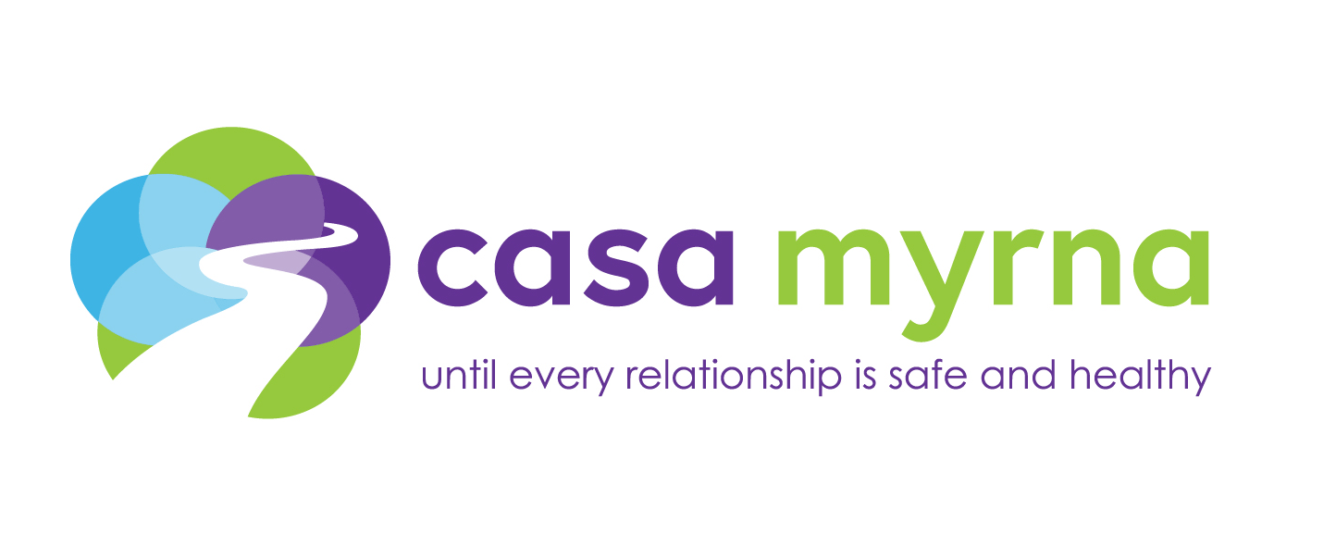

JOB DESCRIPTION

Staff Attorney, Immigration
Legal Advocacy Program
full-time, salaried, exempt

Casa Myrna is Greater Boston’s foremost provider of solutions to end domestic and dating violence. The agency operates three residential programs in Boston for survivors and children made homeless by domestic violence, a comprehensive range of advocacy and supportive services, and SafeLink, Massachusetts’ statewide 24/7 toll-free domestic violence hotline. Casa Myrna believes that every relationship should be safe and healthy, and works to end domestic and dating violence through education, awareness and prevention.

The Legal Advocacy Program is currently looking to add an Immigration Attorney to their team! The Legal Advocacy Program serves clients by representing them in domestic violence-related family law and abuse prevention matters in the courts of Greater Boston; representing survivors in filing affirmative applications for immigration relief; offering brief service and legal advocacy where representation is not provided; and managing a Legal HelpLine for telephone assistance and intake purposes. The Legal Advocacy Program also works collaboratively to address the legal needs of survivors of commercial sexual exploitation at the EVA Center, a survivor-led program of Casa Myrna. The Immigration Attorney will join our growing practice area that specializes in providing survivors with immigration legal services related to domestic violence and sexual exploitation. The Immigration Attorney reports to the Managing Attorney.

Principal Duties and Responsibilities
- Provides legal consultations to Casa Myrna and EVA Center program participants, community clients, and Legal HelpLine callers in order to identify and analyze their immigration-related legal issues and assess cases for protentional immigration relief.
- Educates survivors about their options so they can make their own informed decisions, with the goal of minimizing the risk of outcomes that jeopardize safety and wellbeing.
- Represents immigrant survivors in connection with affirmative petitions for immigration relief related to domestic violence and sexual exploitation, including U-Visas, T-Visas, and VAWA petitions.
- As availability and resources permit, provides brief services and/or legal advocacy in collateral legal matters such as housing, benefits, and restraining orders.
- Participates in administrative tasks associated with expanding immigration practice.
- Conducts training for Casa Myrna staff and external stakeholders about domestic violence and sexual exploitation-related immigration relief and working with immigrant survivors; attends professional development trainings both within Casa Myrna and in the community.
- Collaborates with community-based providers, law enforcement, and legal services to build capacity to respond to the needs and concerns of immigrant survivors.
- Participates in weekly program and case assessment meetings.
- Performs additional duties as assigned by the Managing Attorney.

Qualifications and Requirements
- Committed to Casa Myrna’s mission of ending domestic and dating violence, and promoting social justice and social change.
- J.D. degree; admission to and good standing in a state bar required, with MA bar admission strongly preferred. If not admitted in MA, must be eligible for admission by motion under SJC Rule 3:01 or eligible to practice under SJC Rule 3:04 until eligible to be admitted by motion.
- Spoken fluency in a second language strongly preferred (Spanish, Portuguese, Cape Verdean Creole, Haitian Creole); bi-cultural preferred.
- 2+ years’ experience in providing immigration legal services required; focus on representing survivors of abuse and/or exploitation preferred.
- Demonstrated ability to utilize appropriate, non-judgmental communication techniques when responding to survivors that illustrates sensitivity to their experiences and needs. Prior experience interviewing and counseling survivors of trauma and abuse preferred.
- Ability to work and advocate in a collaborative style with diverse ethnic, cultural, linguistic, and socio-economic groups, as well as diversity based on ability/disability, sexual orientation and religion.
- Familiarity with local legal services providers, community agencies, and resources.
- Computer literacy and strong data entry skills.
- Ability to work independently and in a team.
- Strong organizational skills and ability to multi-task.
- Models and maintains professional boundaries with callers, clients, and colleagues.
- Maintains confidentiality regarding clients and program participants.

Casa Myrna offers generous benefits including:
- Family friendly schedule, generous paid time off and holidays.
- Health, dental, short term disability insurance and retirement savings plan.
- Opportunities for professional development and training.

To apply: please submit cover letter including desired salary and resume to jobs@casamyrna.org with subject line: Immigration Attorney. Please note that resumes without a cover letter will not be considered.

Casa Myrna is an equal opportunity employer committed to workforce diversity and hiring people with diverse life experiences. Survivors, people who are bilingual/bicultural, persons of color, people with disabilities and LGBQ/T people are strongly encouraged to apply.

